# Voting system for deciding where to have lunch

## Testing screenshots (from Google Chrome browser)

**__________________________________________________________**

# Menu

**New menu:**

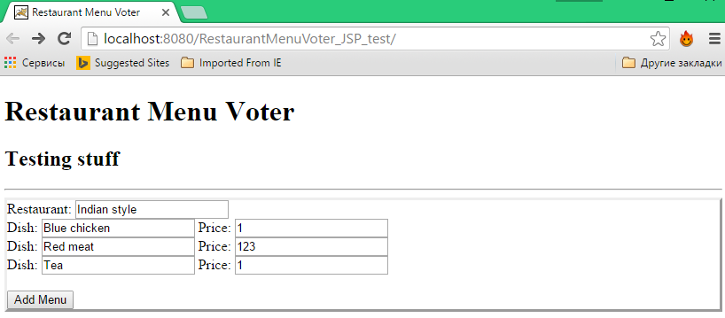

**Result:**

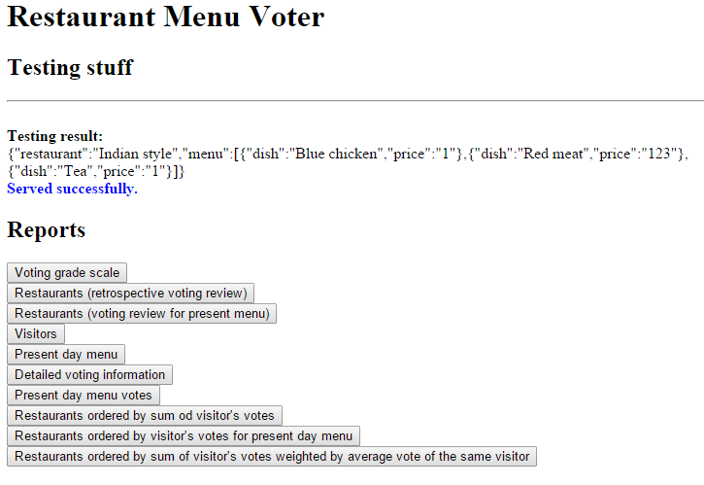

**Incorrect menu data (wrong price):**

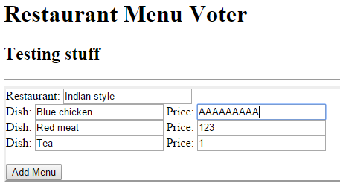

**Result:**

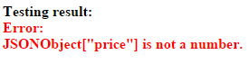

# Voting

**Voting:**

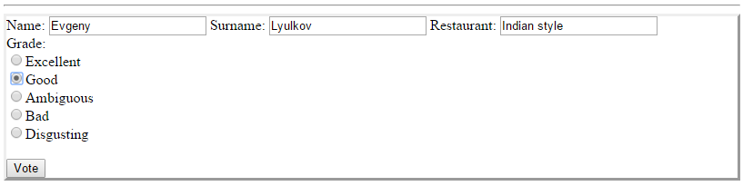

**Result:**

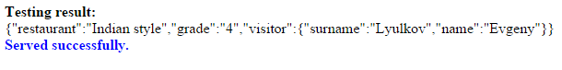

**Voting for a brand new restaurant:**

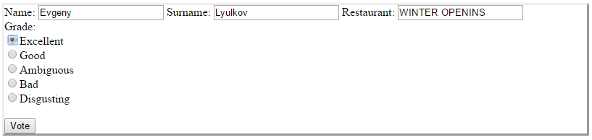

**Result:**

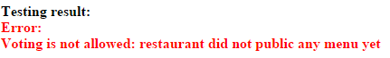

**Late (after 11 am) vote update attempt:**

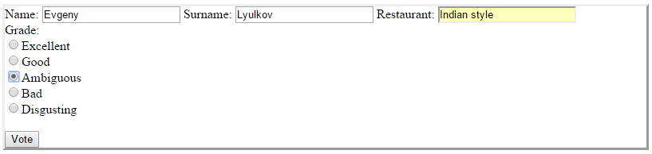

**Result:**



# Reporting

**Report table (SQL DB side) is pre-populated by 10 cooked reports:**

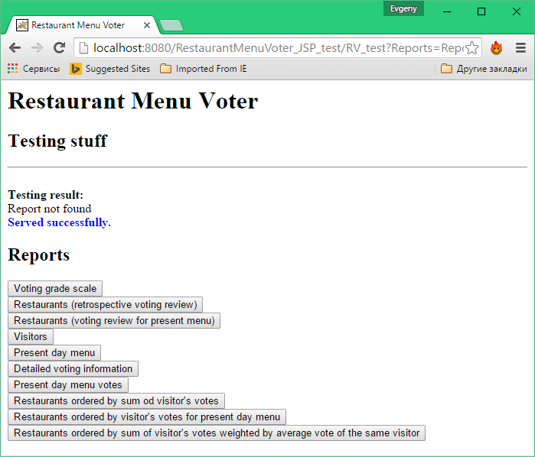

**Reporting results:**



